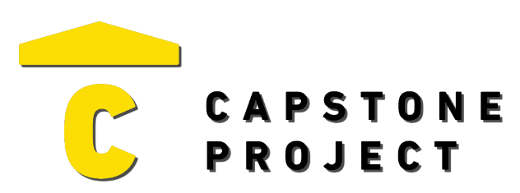
USER FEEDBACK
User Name: Chad Para
What are your thoughts on the project overall?
The project is useful practice on network security.

Was the project enjoyable? What was your favorite part of the project?
I do not care.
What changes would improve the project?
Working database

Capstone Project Ratings:
Project Technology Depth (shows good usage of technology) | High
Project Breadth (number of features and content) | Medium
Professional Presentation (analogous to a real-world product) | High
Implementation Quality (number of bugs and errors) | Medium
Project Completeness (project contains essential functionality) | Medium

Game / Application / Website Ratings:
Visuals (art style, environment, effects) | Mixed
Audio (sound effects, music) | Very Negative
UI (title, menus, UI elements, text) | Mixed
Controls (intuitive, ease of use, ease of navigation) | Positive
Interactivity (fun, engagement, flow) | Very Negative

